*Florida International University*

*School of Computing and Information Sciences*

Software Engineering Focus

Installation/Maintenance Guide

Project Title:

LegalWise 3.0

[http://legalwise3.mybluemix.net/](http://legalwise2ui.mybluemix.net/)

**Team Members:**

Michel Angelo Roger

Renato Almeida

**Product Owner(s)**:

 Jaime Borras

**Mentor(s)**:

Jaime Borras

**Instructor**:

Masoud Sadjadi

Instructions on how the install the LegalWise 3.0 system in your local environment:

This application use Maven as a dependency manager, eclipse as a development platform, and Java 1.8 as SDK environment, this is very important otherwise the project is not going to compile.

1. We need to install eclipse javaEE which include all the artifacts for web development. I recommend the las eclipse release at this moment which is the Neon.
2. Install plugings on eclipse in order to interact with the application code.
   1. Maven and git plugin. Those can be installed on under Help menu -> Install new software

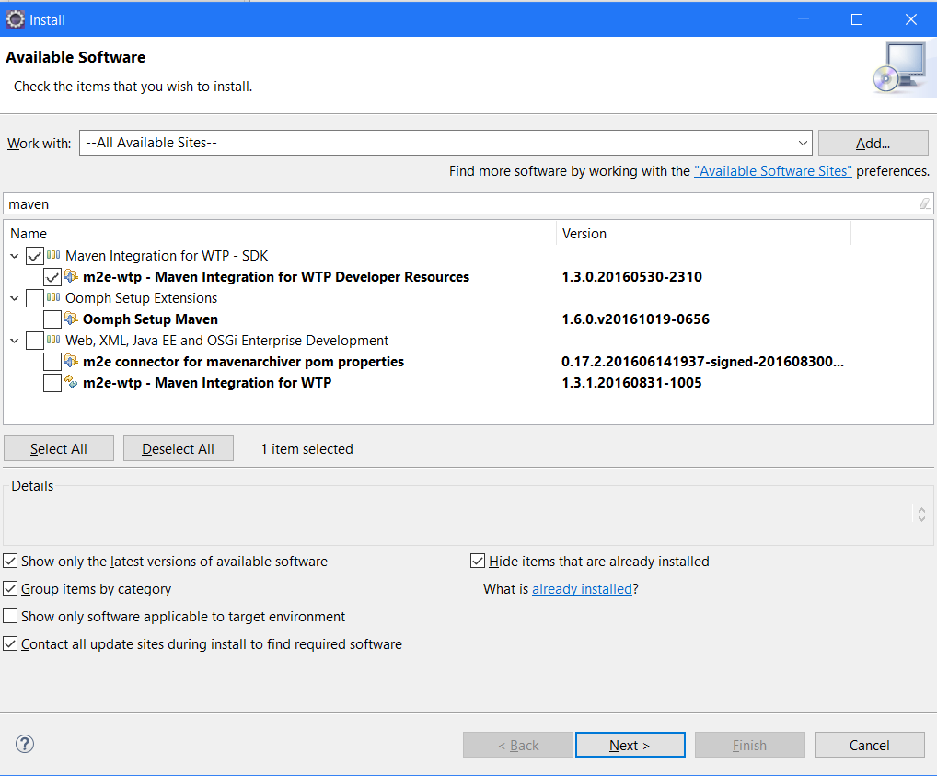

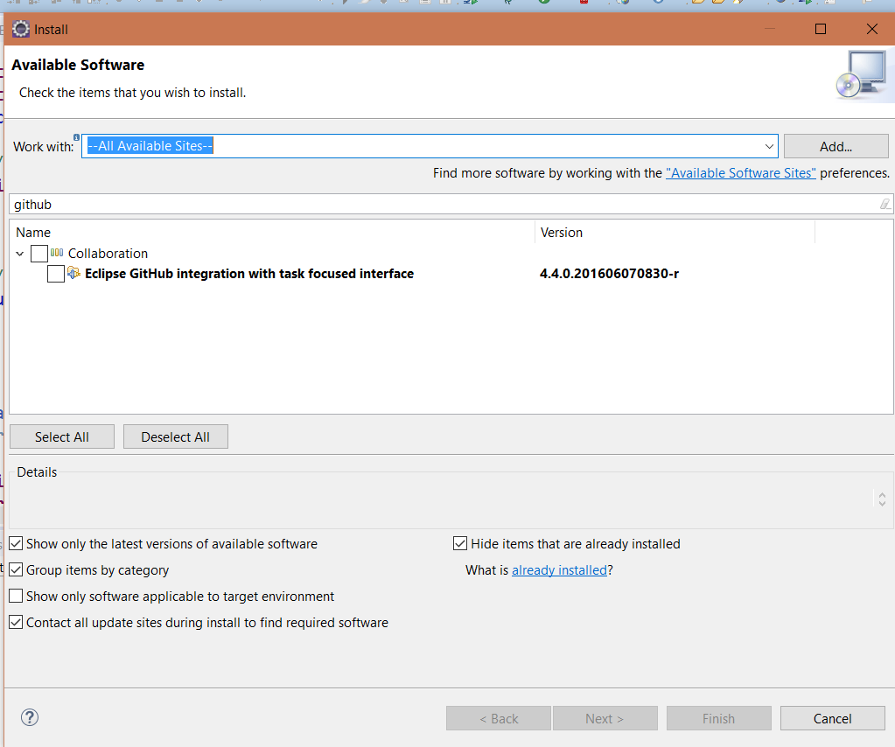

* 1. Liberty Server and IBM blumix pluging those can be installed under the Help menu -> Eclipse Marketplace

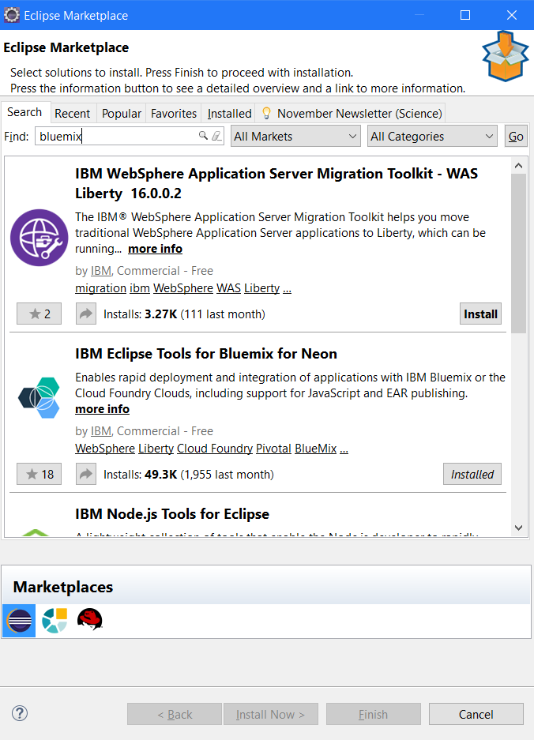

1. We need to import the project
   1. Got to the windows menu -> Show view -> other -> Git -> Git Repository

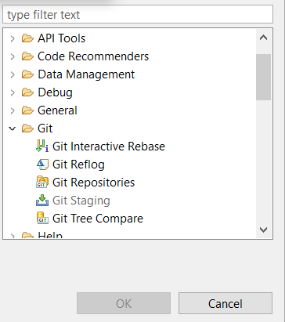

* 1. On the left panel select clone a new repository icon and put the url of the github where the application resides.
  2. The right clicks the folder of the project and click under import.

1. The project will be imported and compiled for you on the IDE. Should look like below.

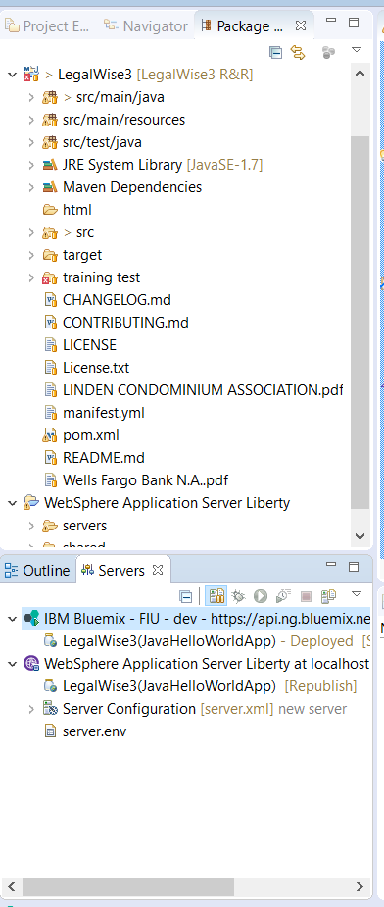

1. The configuration and credential of the application are on the package src/main/resources/rex/xml/env.xml
2. Legalwise 2.0 were using sql database but it is now deprecated still appear on the credential list but it is not used anymore.
3. The project use MongoDB as a storage layer, I recommend to install a local version of the MongoDB on a local pc for development.
4. For browsing the Mongo instance, I recommend MongoDB Compass.

You can also follow the steps below in order to do all of this manual without the help of the IDE.

1. The content of this folder is an Eclipse project. But before opning in eclipse, we should package the project to make sure all dependencies are properly downloaded to your machine. To package the project, follow these steps:
2. While in the project’s folder, open the command prompt or terminal. If you are using windows, just press the Shift + right mouse click and select the option “Open command prompt here”.
3. Simple, type the command “mvn package”.

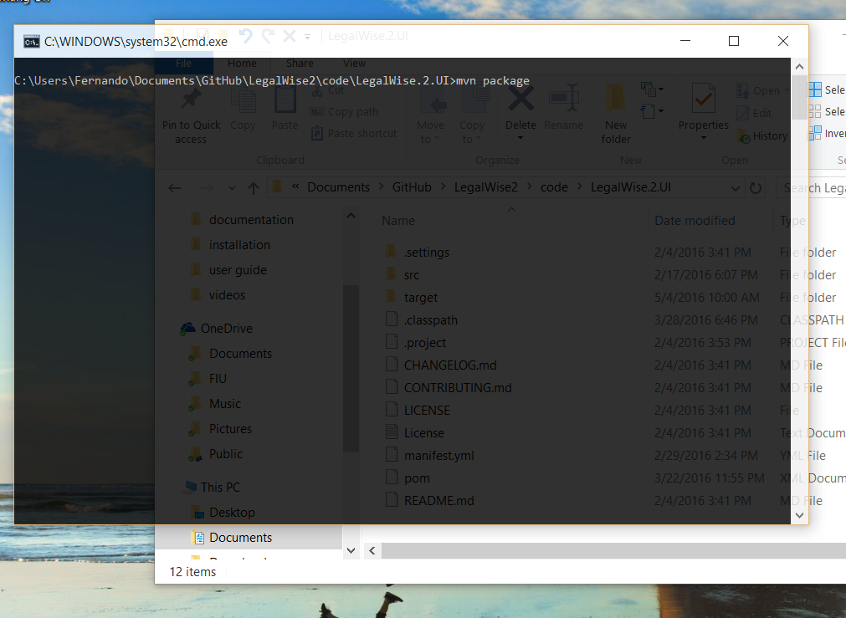

1. After a couple of seconds, you should have all your dependencies in place. Now we can import the project to eclipse.
2. Open Eclipse EE. This release of Eclipse is ideal for web development.
3. In the menu select File > Import…

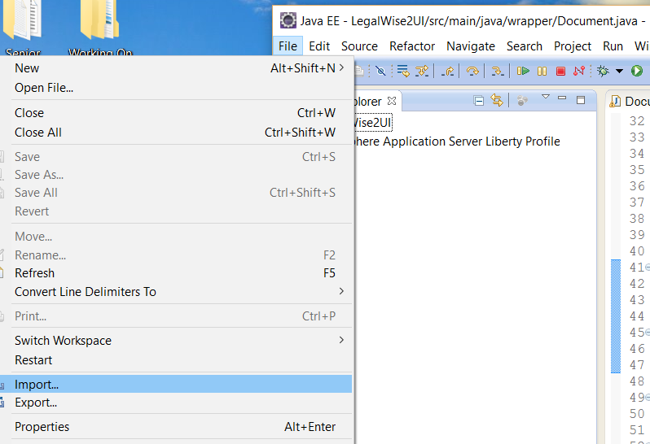

1. Choose the option “Existing Project Into Workspace…” and click next.

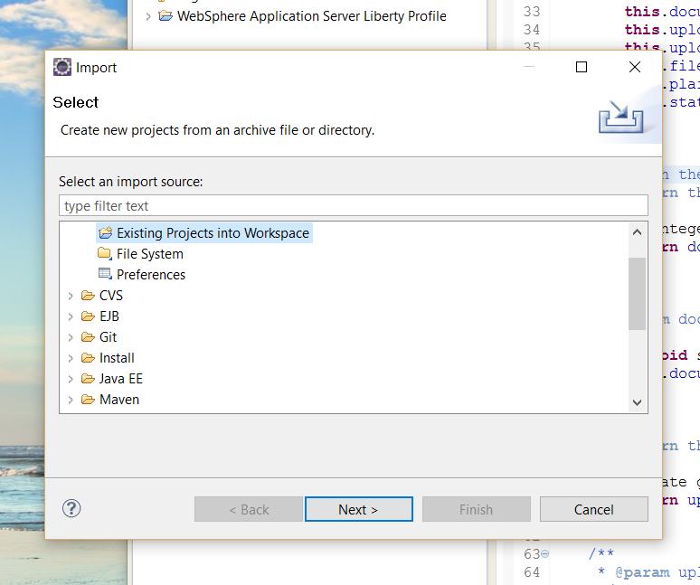

1. In the “Select Root Directory” section, click Browse and find and select the directory of the project. Click OK to proceed.

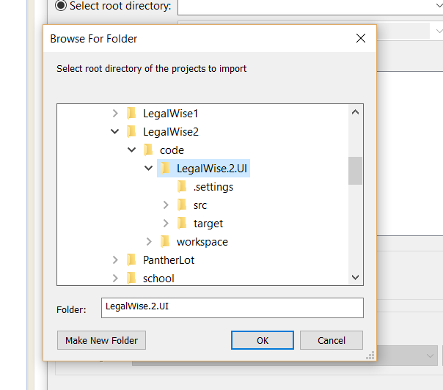

1. After the directory is selected, eclipse will show the projects currently inside the folder. You should see only one. Make sure is selected and click Finish.

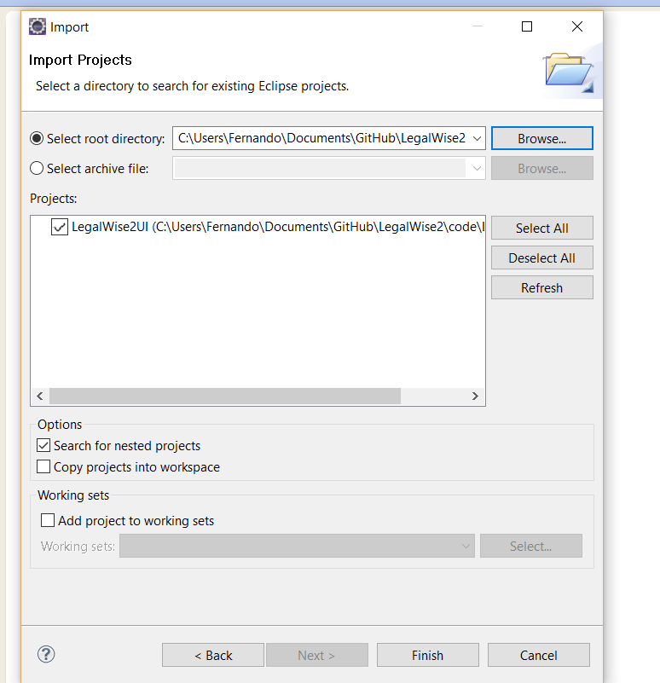

1. After the Eclipse finish working, you should now see you project in your workspace, and are ready to start working on it.

